## **Grit Score**

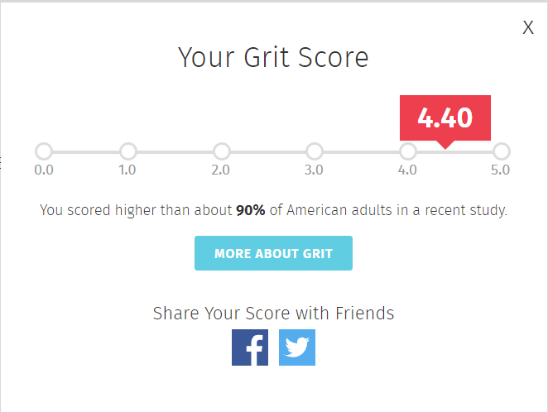

## 

## **Grit Profile**

### **The goal for KodeCamp 4.0:**

My primary goal for KodeCamp 4.0 is to gain a solid understanding of DevOps principles, tools, and practices. Specifically, I aim to learn how to streamline software development, automate processes, and enhance collaboration between development and operations teams.

### **My Why**

Achieving this goal is crucial because DevOps practices are essential in today’s fast-paced software industry. By mastering DevOps, I can:

* **Improve Efficiency:** DevOps helps reduce manual tasks, leading to faster development cycles and quicker releases.
* **Enhance Quality:** Automation ensures consistent deployments and better code quality.
* **Boost Collaboration:** DevOps bridges the gap between development and operations, fostering better teamwork. “TEAMWORK makes the DREAMWORK”
* **Career Advancement**: DevOps skills are highly sought after in the tech industry. By mastering these skills, I’ll enhance my employability and open up exciting career opportunities.
* **Personal Growth**: I’m passionate about working with smart people who will challenge me to push myself harder, as I intend not to stop becoming a better version of myself. Learning DevOps will also allow me to express my communication and problem-solving abilities.
* **Impact**: I want to use DevOps as a starting point for my impact in the tech world. Because I believe impact is the final frontier of achievement.

While pursuing this goal, I anticipate a few challenges:

1. **Time Constraints**: Balancing KodeCamp with my business can be tough, which I intend to overcome through proper schedule planning (TO-DO list) and personal discipline.
2. **Complexity**: DevOps involves learning various tools and skillsets (Operating Systems (Linux OS), Docker, Jenkins, Kubernetes, etc.) which might be overwhelming. I plan to combat that by creating a roadmap to follow, learning incrementally, seeking clarification from mentors, and practicing hands-on.

I believe the urge to succeed conquers the above challenges.

### **My support system**

* **Myself**: A strong belief in one’s self is one's greatest support system.
* **Mentors**: I intend to connect with experienced experts who offer guidance and share their insights.
* **KodeCamp Community**: The KodeCamp community is my strongest support system and has given me a good track to start a beginner in tech.
* **My fellow learners**: My fellow learners are also a support system, as I intend to collaborate with them and participate in group tasks.

### **Action Plan**

Here’s my Specific, Measurable, Achievable, Relevant and Time-bound (SMART) action plan:

1. **Week 1-4: Basics**
   * Learn about DevOps principles, SDLC, Operating System(OS) CI/CD, and version control (Git).
   * Set up a GitHub account and practice basic Git commands.
2. **Week 5-6: Automation Tools**
   * Explore Docker for containerization.
   * Create a simple Dockerized application.
3. **Week 7-8: CI/CD Pipeline**
   * Learn Jenkins for continuous integration.
   * Set up a Jenkins pipeline for a sample project.
4. **Week 9-10: Infrastructure as Code (IaC)**
   * Study Terraform or Ansible for infrastructure automation.
   * Deploy a basic infrastructure on a cloud provider (e.g., AWS, Azure).
5. **Week 10-11: Kubernetes**
   * Understand Kubernetes concepts.
   * Deploy a sample application on a local Kubernetes cluster.
6. **Week 12-13: Monitoring and Logging**
   * Explore tools like Prometheus and Grafana.
   * Set up monitoring for a sample application.
7. **Continuous improvement**

In summary, I believe *“if you want something and you don’t get it. You either don’t want it enough or you are bargaining over the price to pay”*.